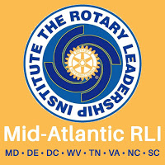
WELCOME TO RLI CHANGING TIMES
PDG Sandy Duckworth
District 7610 RLI Committee Chair
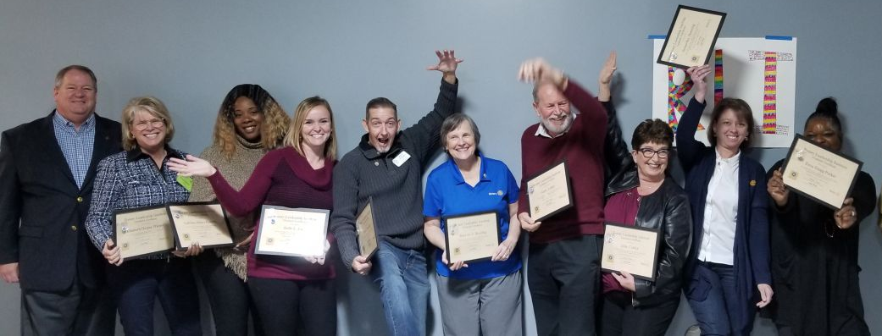
The COVID-19 pandemic has prevented our holding face-to-face RLI events since March. However, we are excited to report that our Mid-Atlantic RLI has been actively involved in creating an Online RLI and the successful results will be rolled out very soon. Also, the RLI Board has announced that where possible, face-to-face events may also be offered. Both formats will be fast-paced, interactive and emphasize both leadership skills and knowledge of Rotary. One format will continue the traditional in-classroom option but will incorporate local/state COVID-19 mandated safety guide-lines. The second will be offered through a new online format, via the same company that
Hosts Go-To-Meetings. Both options will include RLI’s same distinct proficiency levels (Part I, Part II, and Part III) that lead to an RLI Program Certification.

WATCH THIS SPACE
District 7610 RLI will release a Faculty Training schedule in December. If you have questions about RLI, check our website: www.rli33.org, or contact Sandy Duckworth at pdg7610@gmail.com.

